**Movie Booking Project Specification Document**

**Description:**

Create a dynamic and responsive web application for booking movie tickets online for different genres and languages.

**Background of the problem statement:**  
NMS Cinemas is a chain of single screen theatres that screen movie shows of different genres and languages at very genuine prices. It was established in 2004 in Pune, India. Recently, the business analysts noticed a decline in sales since 2010. They found out that the online booking of movie tickets from apps, such as BookMyShow and Paytm were gaining more profit by eliminating middlemen from the equation.

**Features of the application:**

* Registration
* Login
* Payment gateway
* Searching
* Filtering
* Sorting
* Dynamic data
* Responsive and compatible with different devices

**Technologies used:**

* Database management: MySQL and Oracle
* Backend logic: Java programming, NodeJS
* Frontend development: JSP, Angular, Bootstrap, HTML/CSS, and Javascript
* DevOps and production technologies: Git, GitHub

**Application Functionality:**

**Admin Portal:**  
**It deals with all the backend data generation and product information. The admin user should be able to:**

* Add or remove different genres to or from the application to build a rich product line
* Edit movie details like name, ticket price, language, description, and show timings to keep it aligned to the current prices
* Enable or disable the movie shows from the application

**User Portal:**  
**It deals with the user activities. The end-user should be able to:**

* Sign-in to the application to maintain a record of activities
* Search for movie tickets based on the search keyword
* Apply filters and sort results based on different genres
* Add all the selected movie tickets to a cart and customize the purchase at the end
* Experience a seamless payment process
* Receive a booking summary page once the payment is complete

**Architecture:**

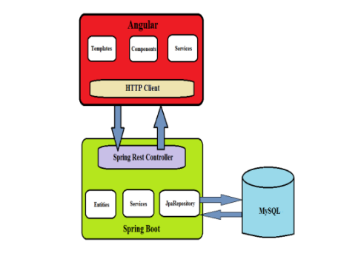

**GitHub**:

<https://github.com/SandeepKumarPamu/MovieBooking.git>